

CAPSTONE PROJECT REPORT
Report 1 – Project Introduction

– Ho Chi Minh City, September 2026 –
Table of Contents
I. Record of Changes 3
II. Project Introduction 4
1. Overview 4
1.1 Project Information 4
1.2 Project Team 4
2. Product Background 4
3. Existing Systems 4
3.1 SAP Extended Warehouse Management 4
3.2 Microsoft Dynamics 365 Supply Chain Management 5
3.3 Odoo Inventory 5
3.4 Oracle NetSuite WMS 5
4. Business Opportunity 5
5. Software Product Vision 5
6. Project Scope & Limitations 6
6.1 Major Features 6
6.2 Limitations & Exclusions 6

I. Record of Changes
Date | A*  M, D | In charge | Change Description
15/09/2026 | A | Trương Lê Huy Hoàng | Initial version of the FSCM Project Introduction
24/09/2026 | M | Trương Lê Huy Hoàng | Aligned Sections 1–6 with the finalized scope and state rules
*A - Added M - Modified D - Deleted

II. Project Introduction

1. Overview

1.1 Project Information
- Project name: FSCM – Short Shelf-Life FMCG Supply Chain Management and Distribution Coordination System with FEFO Optimization
- Project code: FA26SE083
- Group name: GFA26SE63
- Software type: Web Application and Mobile Application

1.2 Project Team
Full Name | Role | Email | Mobile
Le Thi Quynh Chi | Lecturer | chiltq6@fe.edu.vn
Nguyen Thien Nhan | Leader | NhanNTSE184555@fpt.edu.vn
Tran Ngoc Khiet | Member | tranngockhiet22062005@gmail.com
Doan Duc Hai | Member | beu2901@gmail.com
Vo Minh Son | Member | vominhson310805@gmail.com
Truong Le Huy Hoang | Member | hoanghuypeter1182004@gmail.com

2. Product Background
Short shelf-life FMCG products such as dairy, fresh bakery items, and chilled goods must be controlled by Batch/Lot and expiration date. Spreadsheets and general inventory tools can show stock totals, but they do not consistently determine which eligible batch should be allocated to an order. FIFO alone is insufficient because a later receipt may expire earlier than an older receipt.
The target operation is one FMCG distributor that manages a network of warehouses and supplies retail stores. The warehouses are operating locations in the same enterprise and are not divided into a fixed hierarchy. A Sales Representative creates the retail-store order, while the Retail Store Manager participates at receipt confirmation rather than order placement.
FSCM connects approved goods receipt, Batch/Lot inventory, mandatory offline-first mobile ordering for Sales Representatives, order approval, ETA–MLOR eligibility, FEFO allocation, reservation, picking, dispatch evidence, and retail receipt reconciliation. The system separately tracks batch lifecycle, allocation outcomes, and the core order lifecycle so that inventory, reservations, backorders, cancellations, and dispatch records remain auditable.

3. Existing Systems
The following products provide useful references for batch inventory, FEFO picking, and reservation. FSCM adopts relevant concepts while narrowing the solution to the project's retailer-order allocation problem.

3.1 SAP Extended Warehouse Management
Users: warehouse managers and warehouse operators. Relevant capabilities: batch stock, shelf-life expiration dates, warehouse execution, and delivery scheduling. Strength: mature control for complex enterprise warehouses. Gap for this project: its enterprise breadth and configuration effort exceed the focused MVP required for an SME distributor.
Official reference: https://help.sap.com/docs/SAP_ERP/34fc810a607e4ae5a287b6e233b8566f/f18ec95360267214e10000000a174cb4.html

3.2 Microsoft Dynamics 365 Supply Chain Management
Users: inventory, order, and warehouse teams. Relevant capabilities: sales-order inventory reservation, batch control, and warehouse reservation policies. Strength: integrated order and inventory visibility. Gap for this project: FSCM requires an explicit ETA–MLOR eligibility check and a focused multi-warehouse allocation and partial-fulfillment flow.
Official reference: https://learn.microsoft.com/en-us/dynamics365/supply-chain/inventory/reserve-inventory-quantities

3.3 Odoo Inventory
Users: inventory managers, warehouse operators, and sales users. Relevant capabilities: lot tracking, expiration dates, and FEFO removal strategies. Strength: a modular and comparatively accessible inventory workflow. Gap for this project: standard FEFO removal does not express the project's ETA-based MLOR filter, atomic reservation, and split fulfillment rules as one process.
Official reference: https://www.odoo.com/documentation/19.0/applications/inventory_and_mrp/inventory/shipping_receiving/removal_strategies/fefo.html

3.4 Oracle NetSuite WMS
Users: warehouse managers, order managers, and warehouse operators. Relevant capabilities: lot-numbered inventory, FEFO lot assignment, and expiry-date validation. Strength: FEFO support within a broader cloud ERP environment. Gap for this project: its broader ERP scope is not tailored to the project's lightweight SME workflow and documented FEFO-MLOR heuristic.
Official reference: https://docs.oracle.com/en/cloud/saas/netsuite/ns-online-help/article_161009052865.html

4. Business Opportunity
FSCM addresses the gap between spreadsheets or basic inventory tools and large enterprise warehouse systems. An FMCG distributor needs controlled receipt approval, Batch/Lot and expiry visibility, reliable allocation, and auditable dispatch and receipt evidence without adopting an oversized ERP solution.
The product first filters stock by service range, available quantity, committed receiving deadline, and retailer–SKU MLOR. It then applies FEFO across eligible batches, using distance and available quantity only as tie-breakers. A tentative allocation becomes Reserved only after atomic revalidation. If eligible stock is insufficient, the confirmed retailer policy determines whether the available quantity may be reserved and the remainder is Backordered or Cancelled with retailer consent.

5. Software Product Vision
For an FMCG distributor managing short shelf-life products across a peer warehouse network, FSCM is a web and mobile system for approved receipt, Batch/Lot inventory, offline sales ordering, ETA–MLOR eligibility, FEFO allocation, reservation, picking, dispatch, and retail receipt reconciliation. It provides consistent batch selection, controlled shortage handling, and an auditable flow from goods receipt to receiving evidence.
The selected solution stack uses React and Chart.js for the web portal, ASP.NET Core Web API for REST services, Flutter for the mobile application, and Azure Database for PostgreSQL for transactional data. Mandatory offline Sales ordering uses SQLite, a local queue, WorkManager, and REST synchronization. Azure Blob Storage stores evidence; Microsoft Entra ID supports identity; a PostgreSQL transactional outbox, a custom worker, and Azure Functions Timer Trigger support asynchronous and scheduled work. Vercel, GitHub Actions, Azure Notification Hubs, Azure Monitor, Azure DNS, Azure Front Door, Web Application Firewall, and Azure Key Vault support delivery and operations.

6. Project Scope & Limitations
The mandatory MVP covers approved goods receipt, Batch/Lot inventory and date tracking, offline-first Sales ordering, order approval, ETA–MLOR eligibility, FEFO allocation, atomic reservation, shortage handling, picking, dispatch evidence, retail receipt reconciliation, controlled write-off, dashboards, notifications, and audit. Transportation coordination and delivery completion, forecasting, promotions, AI functions, and other advanced capabilities remain optional.

6.1 Major Features
FE-01: Master data and access control. Manage SKUs, warehouses, retail stores, service ranges, retailer-SKU MLOR values, processing and transit-time configurations, users, and roles. Apply role-based permissions and audit relevant actions.

FE-02: Goods receipt and Batch/Lot inventory. The Warehouse Keeper records SKU, quantity, Batch/Lot, and expiration date. The system generates the Batch ID, and inventory increases only after Administrator approval.

FE-03: Batch date tracking. A daily date tracker changes batches from Normal to Near-date to Expired and prevents expired stock from being allocated or issued.

FE-04: Mandatory offline-first mobile sales ordering. The Sales Representative uses the Flutter application to view cached catalog and availability data, create orders while offline, store them in a local SQLite queue, and synchronize idempotently through WorkManager and REST when connectivity returns.

FE-05: Order approval and core state control. The Administrator approves or rejects orders and enforces Pending Approval → Confirmed → Dispatched with RBAC and audit history. Completed is not a core allocation state and is added only if the optional transportation and delivery-completion module is implemented.

FE-06: Service-range, ETA, and MLOR eligibility. For each candidate warehouse and batch, check available quantity and service range, then require ETA ≤ committed receiving deadline and EXP − ETA ≥ m(c,s) × SL(s), where 0 < m(c,s) < 1. Only batches that pass both comparisons continue to FEFO ranking.

FE-07: FEFO multi-warehouse allocation. Combine eligible batches into one list and rank them lexicographically by earliest expiration date, then shorter distance, then greater available quantity. Allocate across multiple batches or warehouses when required. The calculation result is Tentative and does not change physical or reserved quantity.

FE-08: Partial policy, allocation outcomes, and atomic reservation. Recheck ETA and available-for-reservation before changing a Tentative allocation to Reserved using Optimistic Locking. If the full quantity cannot be supplied and partial fulfillment is not allowed, reserve nothing and keep the line unfulfilled or waiting for stock. If partial fulfillment is allowed, reserve the eligible quantity and set the remainder to Backordered by default, or Cancelled only when policy permits and the retailer consents. On a reservation conflict, release the current attempt, reload inventory, and rerun allocation idempotently.

FE-09: Picking, goods issue, and dispatch evidence. Generate warehouse-Batch/Lot-quantity picking lists. The Warehouse Keeper confirms issued quantities, captures a dispatch photo, and moves the order to Dispatched.

FE-10: Mandatory retail receipt reconciliation. The Retail Store Manager enters the received Batch/Lot and actual quantity, attaches a receipt photo, and records discrepancies against dispatch evidence without creating retail-store inventory. Manual Batch/Lot entry is core; QR/barcode scanning is an optional convenience.

FE-11: Write-off, dashboard, notifications, and audit. Control write-off through available-quantity validation, photo evidence, and multi-level approval. Show Batch/Lot inventory, near-date ratio, warehouse and SKU filters, operational KPIs, notifications, and action history.

FE-12 (Optional): Transportation coordination and delivery completion. Plan routes, assign vehicles or drivers, monitor delivery and cold-chain data, calculate delivery KPIs, and move a dispatched order to Completed after confirmed delivery.
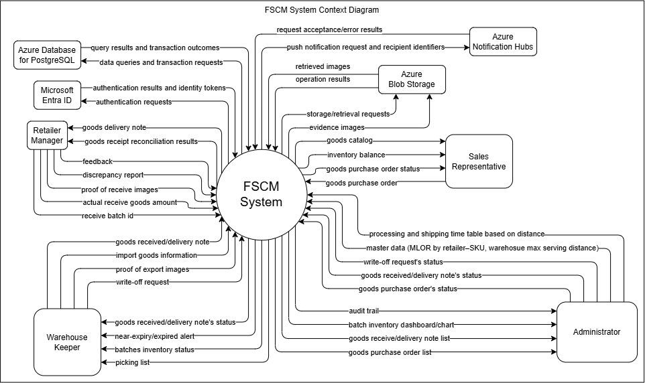

6.2 Limitations & Exclusions
LI-01: Enterprise and warehouse boundary. The system serves one FMCG distributor and its warehouse network. Warehouses are treated as peer operating locations rather than a fixed hierarchy, and the product is not a multi-tenant marketplace.

LI-02: Retail Store Manager boundary. The Sales Representative creates retail-store orders. The Retail Store Manager does not place orders but does confirm receipt, reconcile Batch/Lot and quantity, attach a photo, and report discrepancies.

LI-03: Retail-store inventory exclusion. Receipt reconciliation records the delivered Batch/Lot and quantity only. The system does not create or manage inventory, storage locations, point-of-sale stock, or shrinkage at the retail store.

LI-04: ETA, transportation, and completion boundary. ETA is an estimate used for receiving-deadline and MLOR eligibility, not a guarantee of actual delivery time. Route planning, vehicle or driver assignment, live GPS, cold-chain monitoring, proof of delivery by transport personnel, on-time KPI, and the Completed delivery state belong to the optional transportation module.

LI-05: Heuristic and shipment limitation. FEFO, distance, and available quantity form a lexicographic project heuristic; the system does not claim globally optimal cost or allocation across all orders. The MVP does not impose a warehouse-count limit or minimum shipment quantity, so small split shipments may occur. This is a declared limitation, not an optional feature.

LI-06: MLOR policy. MLOR is configured for each retailer-SKU with 0 < m(c,s) < 1. The system does not automatically reduce MLOR, extend the receiving deadline, or widen the service range when eligible stock is insufficient.

LI-07: Multi-warehouse and partial-fulfillment boundary. Using several batches or warehouses to fully satisfy an order line is not partial fulfillment. Only after every eligible batch has been considered may the retailer policy allow the available quantity to be Reserved and the remainder set to Backordered or Cancelled with retailer consent. If partial fulfillment is disallowed, no tentative quantity is reserved.

LI-08: Mobile and offline boundary. Offline-first mobile support is mandatory for Sales Representative catalog access, order capture, local queuing, and synchronization. Approval, allocation, reservation, warehouse execution, receipt reconciliation, and administration require server connectivity. QR/barcode scanning and transportation delivery completion are optional.

LI-09: Deferred optional functions. Transportation coordination and Completed delivery status, forecasting, MAPE, safety stock, promotions, OCR and LLM label processing, computer-vision shelf analysis, QR/barcode convenience, extended retail recall tracing, and cold-chain functions are outside the mandatory MVP.

LI-10: Technology boundary. The initial solution uses a modular application and REST APIs. Microservices, a dedicated API-management layer, and advanced event-streaming infrastructure are not required for the MVP.

